29.74: a) For clarity, figure is rotated so  comes out of the page.

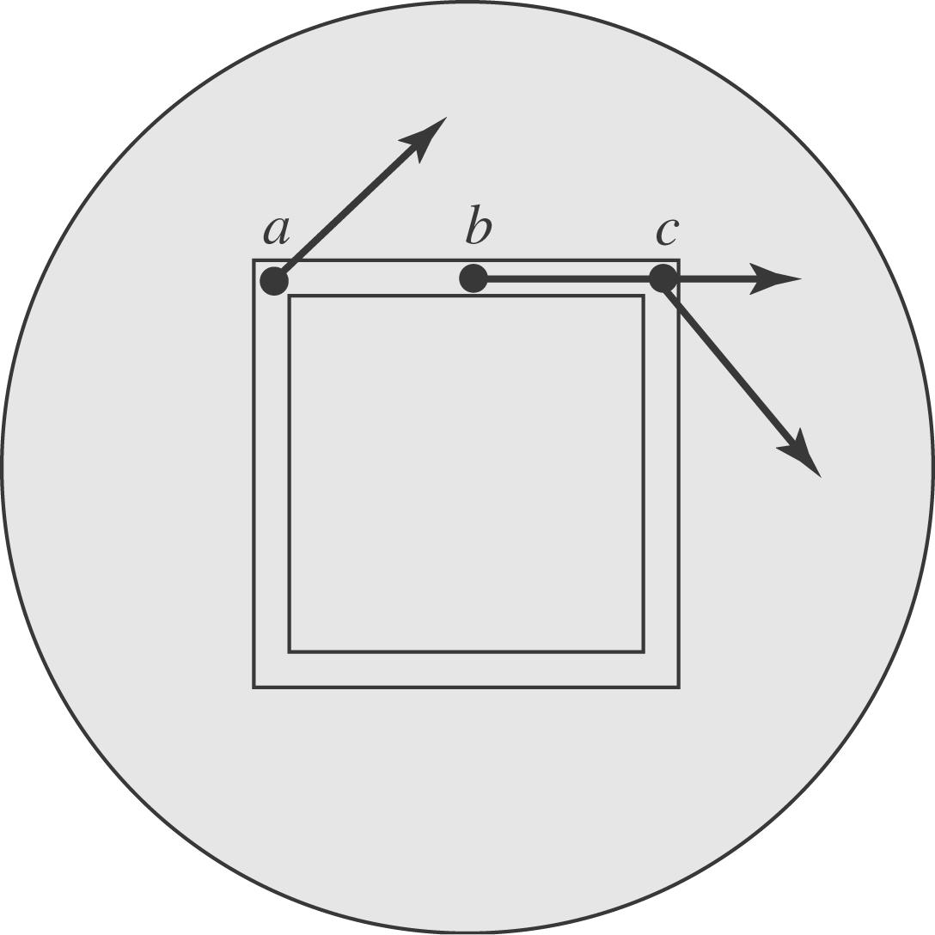

- To work out the amount of the electric field that is in the direction of the loop at a general position, we will use the geometry shown in the diagram below.
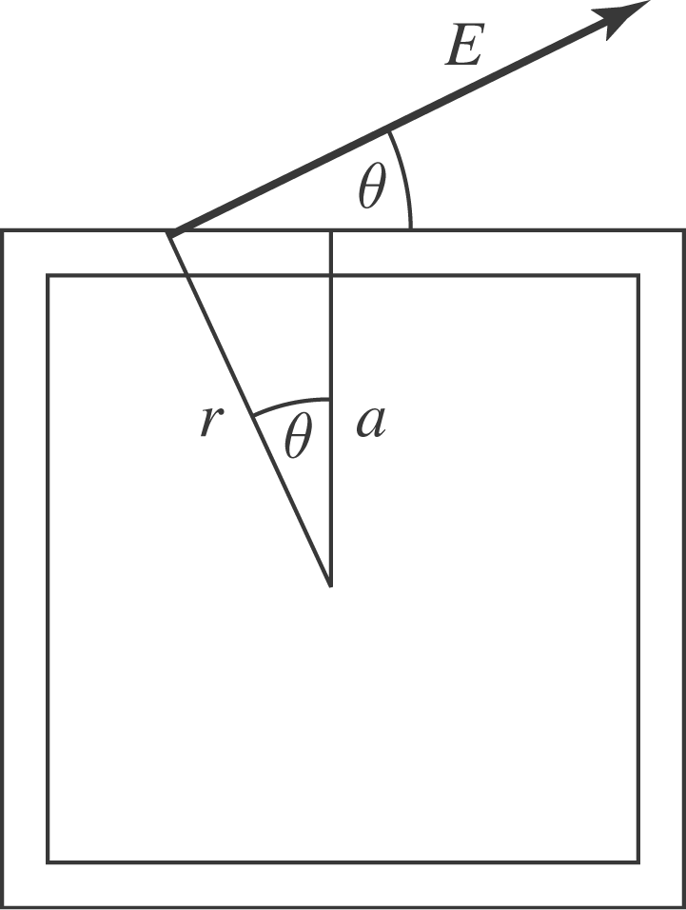

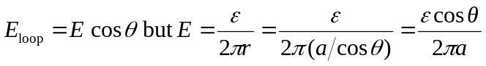
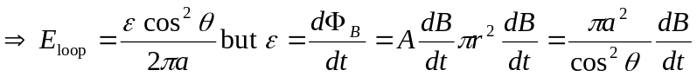
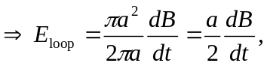 which is exactly the value for a ring, obtained in Exercise 29.29, and has no dependence on the part of the loop we pick.
c) 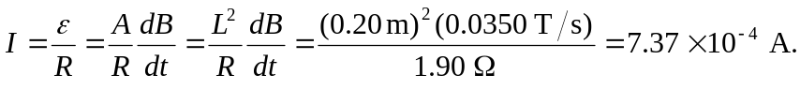
d) 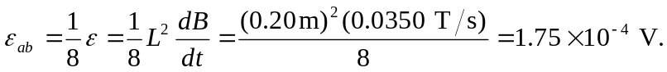
But there is potential drop 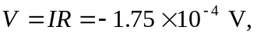 so the potential difference is zero.

